Story at-a-glance
- The first randomized controlled trial of more than 6,000 individuals to assess the effectiveness of surgical face masks against SARS-CoV-2 infection found masks did not statistically significantly reduce the incidence of infection
- Among mask wearers, 1.8% ended up testing positive for SARS-CoV-2, compared to 2.1% among controls. When they removed the people who did not adhere to proper mask use, the results remained the same — 1.8%, which suggests adherence makes no significant difference
- Among those who reported wearing their face mask “exactly as instructed,” 2% tested positive for SARS-CoV-2 compared to 2.1% of the controls
- 1.4% tested positive for antibodies at the end of the month-long study compared to 1.8% of controls
- 0.5% in the mask group and 0.6% tested positive for one or more respiratory viruses other than SARS-CoV-2
The first randomized controlled trial^{1,2} to assess the effectiveness of surgical face masks against SARS-CoV-2 infection specifically — which journals initially refused to publish — is finally seeing the light of day.
The so-called “Danmask-19 Trial,” published November 18, 2020, in the Annals of Internal Medicine,³ included 3,030 individuals assigned to wear a surgical face mask and 2,994 unmasked controls. Of them, 80.7% completed the study.
To qualify, participants had to spend at least three hours per day outside the home and not be required to wear a mask during their daily work. At the end of the study, participants reported having spent a median of 4.5 hours per day outside the home.
For one month, participants in the mask group were instructed to wear a mask whenever they were outside their home. Surgical face masks with a filtration rate of 98% were supplied. In accordance with recommendations from the World Health Organization, participants were instructed to change their mask after eight hours.
Antibody testing was performed before the outset and at the end of the study period. At the end of the month, they also submitted a nasal swab sample for PCR testing.

What the Danmask-19 Trial Found
The primary outcome was a positive PCR test, a positive antibody test result (IgM or IgG) during the study period, or a hospital-based diagnosis of COVID-19. Secondary end points included PCR evidence of infection with other respiratory viruses.
Based on the adherence scores reported, 46% of participants always wore the mask as recommended, 47% predominantly as recommended and 7% failed to follow recommendations. So, what did they find? As you might expect, there’s a reason why the researchers had such a hard time getting this study published:
- Among mask wearers, 1.8% (42 participants) ended up testing positive for SARS-CoV-2, compared to 2.1% (53) among controls. When they removed the people who reported not adhering to the recommendations for use, the results remained the same — 1.8% (40 people), which suggests adherence makes no significant difference.
- 1.4% (33 participants) tested positive for antibodies compared to 1.8% (44) of controls.
- Among those who reported wearing their face mask “exactly as instructed,” 2% (22 participants) tested positive for SARS-CoV-2 compared to 2.1% (53) of the controls.
- 52 participants in the mask group and 39 in the control group reported COVID-19 in their household. Of these, two participants in the mask group and one in the control group developed SARS-CoV-2 infection — a finding that suggests “the source of most observed infections was outside the home.”
- 0.5% (nine participants) in the mask group and 0.6% (11 individuals) tested positive for one or more respiratory viruses other than SARS-CoV-2 (secondary outcome).

Masks May Lower, or Raise, Infection Risk
All in all, this landmark COVID-19-specific study failed to deliver good news to those who insist face masks are a crucial component of the pandemic response. Masks may reduce your risk of SARS-CoV-2 infection by as much as 46%, or it may increase your risk by 23%. In other words, the preponderance of evidence still shows that masks have virtually no impact on viral transmission.
Another take-home point that you get from this study, which Del Bigtree points out in The Highwire video report above, is that the vast majority — 97.9% of those who didn’t wear masks, and 98.2% of those who did — remained infection free.
So, we are destroying economies and lives around the world, for what, exactly? To protect a small minority from getting a positive PCR test result which, as detailed in “Asymptomatic ‘Casedemic’ Is a Perpetuation of Needless Fear,” means little to nothing. As reported by the authors:⁴
“Although no statistically significant difference in SARS-CoV-2 incidence was observed, the 95% CIs are compatible with a possible 46% reduction to 23% increase in infection among mask wearers.
These findings do offer evidence about the degree of protection mask wearers can anticipate in a setting where others are not wearing masks and where other public health measures, including social distancing, are in effect …
Transmission of SARS-CoV-2 may take place through multiple routes. It has been argued that for the primary route of SARS-CoV-2 spread — that is, via droplets — face masks would be considered effective, whereas masks would not be effective against spread via aerosols, which might penetrate or circumnavigate a face mask. Thus, spread of SARS-CoV-2 via aerosols would at least partially explain the present findings …
The present findings are compatible with the findings of a review of randomized controlled trials of the efficacy of face masks for prevention (as personal protective equipment) against influenza virus …
Our results suggest that the recommendation to wear a surgical mask when outside the home among others did not reduce, at conventional levels of statistical significance, the incidence of SARS-CoV-2 infection in mask wearers in a setting where social distancing and other public health measures were in effect, mask recommendations were not among those measures, and community use of masks was uncommon.”

Government Tyrants Double Down on Mask Mandates
The researchers point out that results could potentially turn out differently if everyone were wearing a mask. At the time of the study, Danish authorities did not recommend universal mask use and most Danes did not wear them. Hence “participants’ exposure was overwhelmingly to persons not wearing masks.”
That possibility, however, is a big “if,” and not sufficient to mandate universal mask wearing. Any claim to such effect is nothing but a wholly unscientific guess. Despite that, many local leaders are now doubling down on mask mandates, some even requiring them to be worn inside your own home when anyone outside the family is present and even if physical distancing can be maintained.⁵
As an example of extremes, a June 2020 Harvard University paper^{6,7} even suggested couples should wear face masks during sex. Others are tripling down on masks, recommending you wear two or even three at the same time.⁸ Former Food and Drug Administration commissioner Dr. Scott Gottlieb is urging Americans to wear N95 surgical masks whenever possible.⁹

Epidemic of Spineless Leadership
Missing entirely from most recommendations is common-sense health guidance known to improve your immune function and lower your infection risk naturally, such as supplementing with vitamin D, NAC, melatonin, quercetin and zinc.
As noted by Angela Rasmussen, a virologist and affiliate of the Georgetown Center for Global Health Science and Security, in a November 15, 2020, op-ed in The Guardian,¹⁰ our immune systems know how to handle the virus; it’s our politicians who have failed to cope with it. She writes:¹¹
“Most of the evidence in both COVID-19 patients and animal models shows that the immune response to this is quite typical for an acute viral infection. Initially, the body ramps up high levels of IgG antibodies, but after the infection is cleared, those antibodies drop to a baseline level, which may be below the limit of detection of some serological tests.
Antibodies are produced by B-cells, a specialized type of immune cell that recognizes a specific antigen, or viral target. When an infection is cleared, B-cells producing antibodies convert from being plasma cells, which are specialized to pump out massive quantities of SARS-CoV-2-specific antibodies, to being memory B-cells.
These cells produce lower levels of IgG antibody; but, importantly they persist in the body for years. If they are re-exposed to SARS-CoV-2, they rapidly convert to plasma cells and begin producing high levels of antibody again.
There is no indication that most COVID-19 patients are not developing immune memory, and animals experimentally infected with SARS-CoV-2 are protected against rechallenge with high doses of virus …
Furthermore, antibodies are not the only important part of the immune system. T-cells are also a key component to the immune response. They come in two flavors: helper T-cells, which coordinate immune responses and facilitate immunological memory, and killer T-cells, which kill infected cells. Previous studies have shown that SARS-CoV-2 infection induces robust T-cell responses.”
As noted by Rasmussen, the data collected on the responses of T-cells to SARS-CoV-2 infection “underscore that SARS-CoV-2 is not an anomalous virus capable of miraculous feats of immune evasion.”
No matter how strictly mask laws are enforced nor the level of mask compliance the population follows, cases all fall and rise around the same time. ~ Yinon Weiss
In other words, provided your immune function is normal, the virus is as vulnerable as any other virus and you’re not destined to die just because you develop symptoms. So, the reason we’re in the situation we’re now in, Rasmussen says, is not because SARS-CoV-2 is somehow different or more lethal than anything that has come before. We’re in this situation due to political failures.

Mask Mandates Have Had No Impact on Infection Trends
Other data analyses that add support to the Danish study’s results include Yinon Weiss’ work presented in his article¹² “These 12 Graphs Show Mask Mandates Do Nothing to Stop COVID.” In it, he shows that states’ mask rules appear to have had nothing to do with infection rates, which is what you’d expect if masks don’t work.
Weiss points out that “No matter how strictly mask laws are enforced nor the level of mask compliance the population follows, cases all fall and rise around the same time.” To see all of the graphs, check out Weiss’ article¹³ or Twitter thread.¹⁴ Here are just a select few to bring home the point:
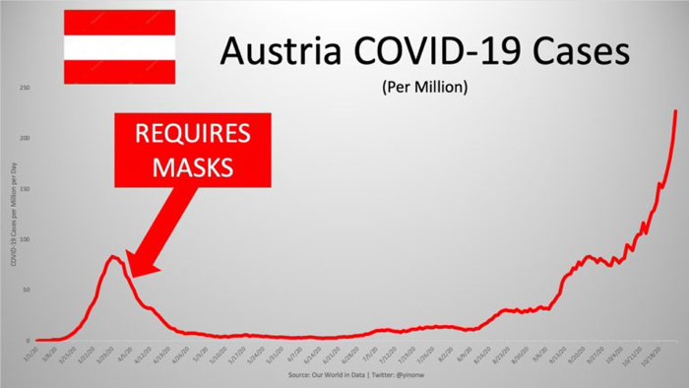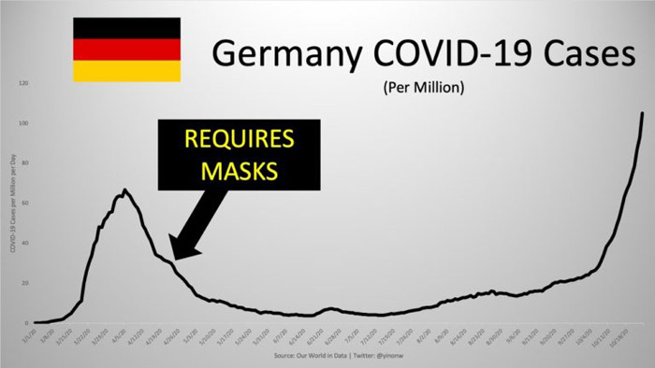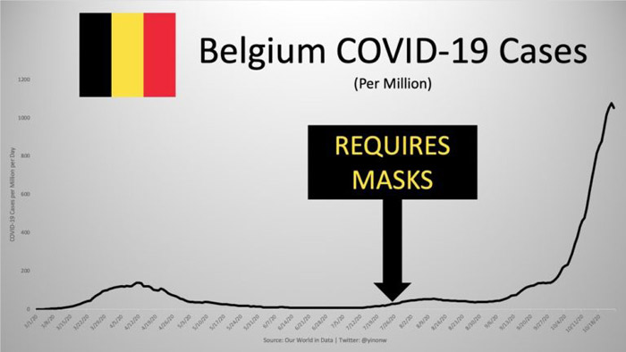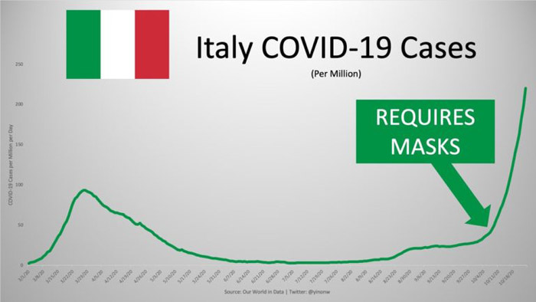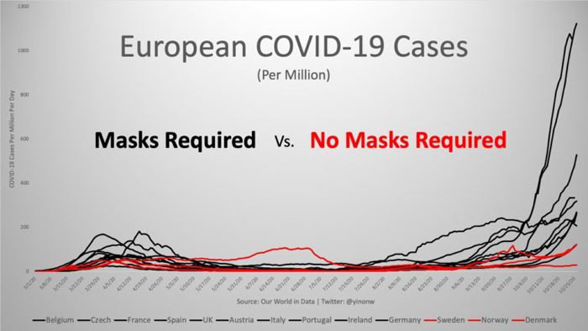

Masks Delay Inevitable Acceptance of COVID-19 Reality
What everyone needs to come to terms with is that we have a new respiratory virus in town — one that may stay with us indefinitely. The question then becomes, just how long do we lock ourselves in our homes and shun all social relationships?
How long do we neglect our children’s education and social development by keeping schools closed? How long do we leave our elderly family members to languish in isolation? A better part of the global population has essentially stopped living altogether, and for what? For fear of an illness that 99.7% of people recover from¹⁵ — an illness that is as likely to kill you as the seasonal influenza if you’re under 60.¹⁶
Data clearly show that COVID-19 has not resulted in excess mortality, meaning the same number of people who die in any given year, on average, have died in this year of the pandemic.^{17,18} Several studies^{19,20,21,22,23,24,25,26} also suggest immunity against SARS-CoV-2 infection is far more widespread than anyone imagined.
In an October 28, 2020, Wall Street Journal opinion piece,²⁷ Joseph Ladapo, an associate professor at UCLA’s David Geffen School of Medicine, points out that we really must accept reality and move on with life, unpredictable as it may be. He writes:
“By paying outsize and scientifically unjustified attention to masking, mask mandates have the unintended consequence of delaying public acceptance of the unavoidable truth.
In countries with active community transmission and no herd immunity, nothing short of inhumane lockdowns can stop the spread of COVID-19, so the most sensible and sustainable path forward is to learn to live with the virus.
Shifting focus away from mask mandates and toward the reality of respiratory viral spread will free up time and resources to protect the most vulnerable Americans ...
Until the reality of viral spread in the U.S. … is accepted, political leaders will continue to feel justified in keeping schools and businesses closed, robbing young people of the opportunity to invest in their futures, and restricting activities that make life worthwhile.”

There’s Nothing to Fear but Fear Itself
Hopefully, if you’ve been reading this newsletter, you’re no longer incapacitated with fear and are capable of making more level-headed decisions based on the data at hand rather than the fear porn published in the daily papers. For the latest news and top tips for combating COVID-19, check out my Coronavirus Resource Page.
Everything really points to this pandemic being overblown and prolonged for purposes that have nothing to do with saving lives and everything to do with “resetting” the global financial and power structures — none of which will benefit us.
The lockdowns are essentially just conditioning you to accept a radically new way of life — one in which we have limited ability to travel or work, one in which we’re conditioned to being partially or wholly dependent on a government handout, one in which we must submit to being tracked and surveilled with little or no right to privacy, one in which the government dictates how you can spend your time, where you can go, who you can spend time with and for how long.
Eventually, once the global economies are in irreparable shambles, the central banks will roll out a debt erasure program to solve all our problems. The price will be your humanity, your freedom. Will you pay it? Or will you resist the whole deviled scheme while you still can?

